**MySQL Assignment-3**

1. Write a query to retrieve the product details for order 10103.

Query:

SELECT p.*

FROM orderdetails od

JOIN products p ON od.productCode = p.productCode

WHERE od.orderNumber = 10103;

Output:

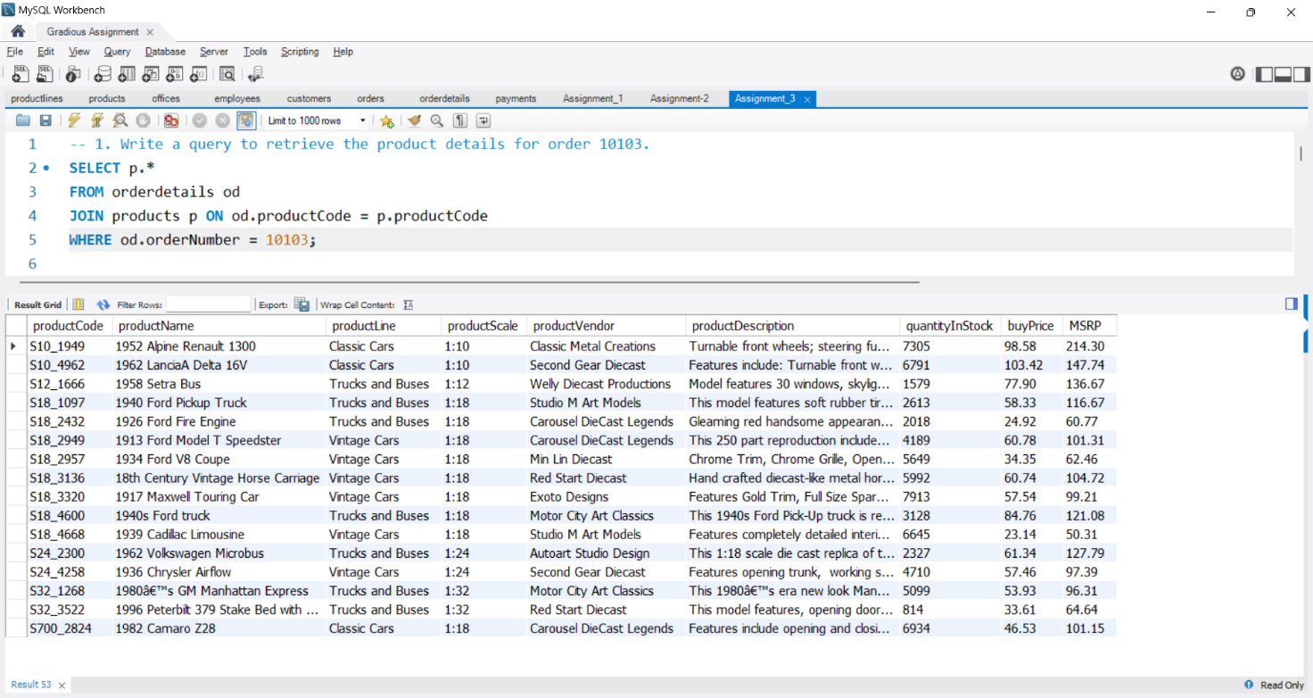

2. Write a query to get the customer information for order 10127

Query:

SELECT c.*

FROM orders o

JOIN customers c ON o.customerNumber = c.customerNumber

WHERE o.orderNumber = 10127;

Output:

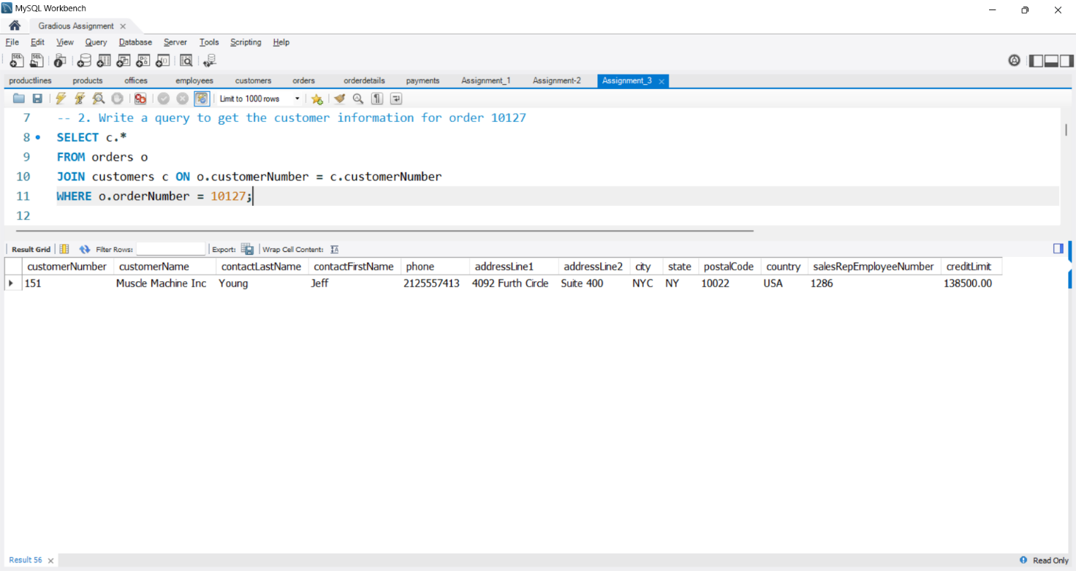

3. Write a query to retrieve the employee information for customer 166

Query:

SELECT e.*

FROM employees e

JOIN customers c ON c.salesRepEmployeeNumber = e.employeeNumber

WHERE c.customerNumber = 166;

Output:

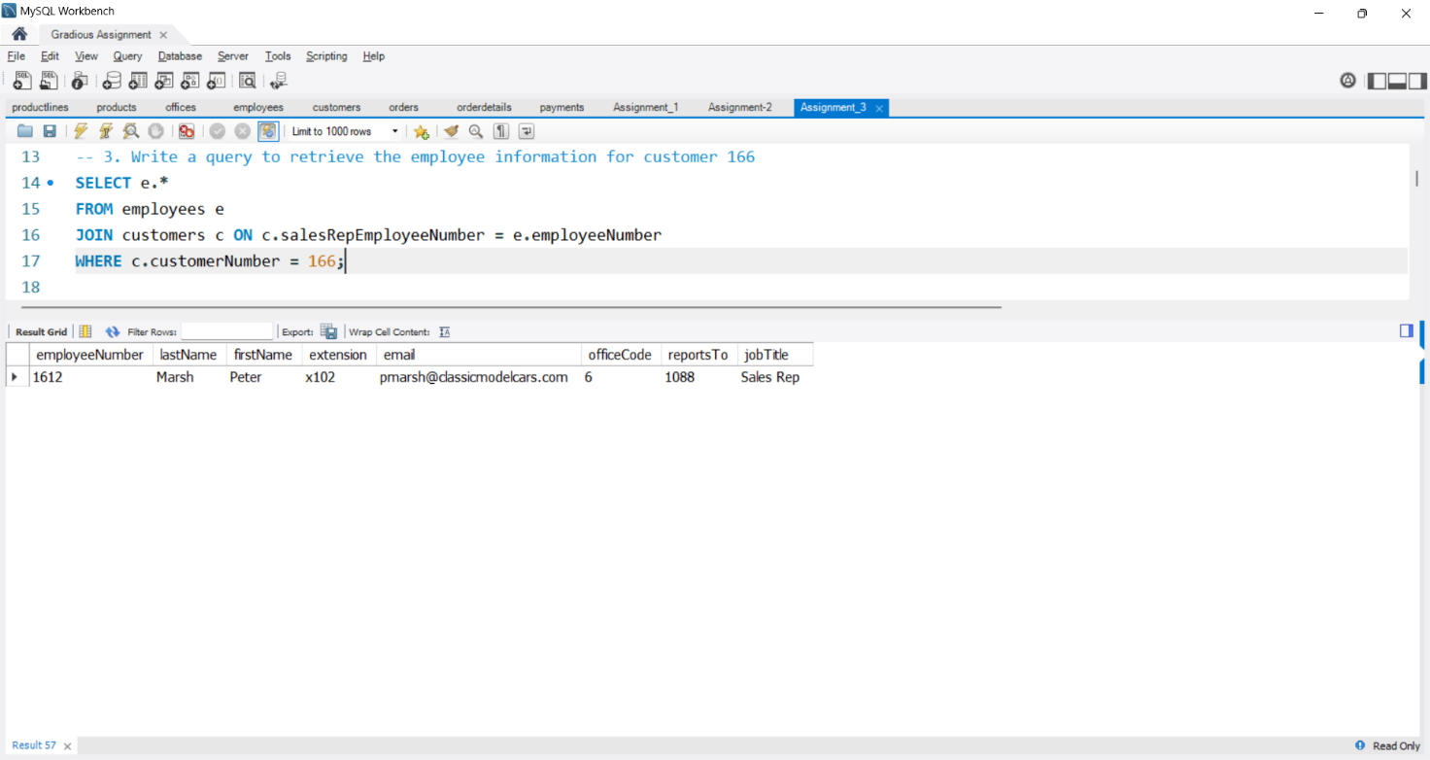

4. Write a query to get the official information for office code 4

Query:

SELECT *

FROM offices o

WHERE o.officeCode = 4;

Output:

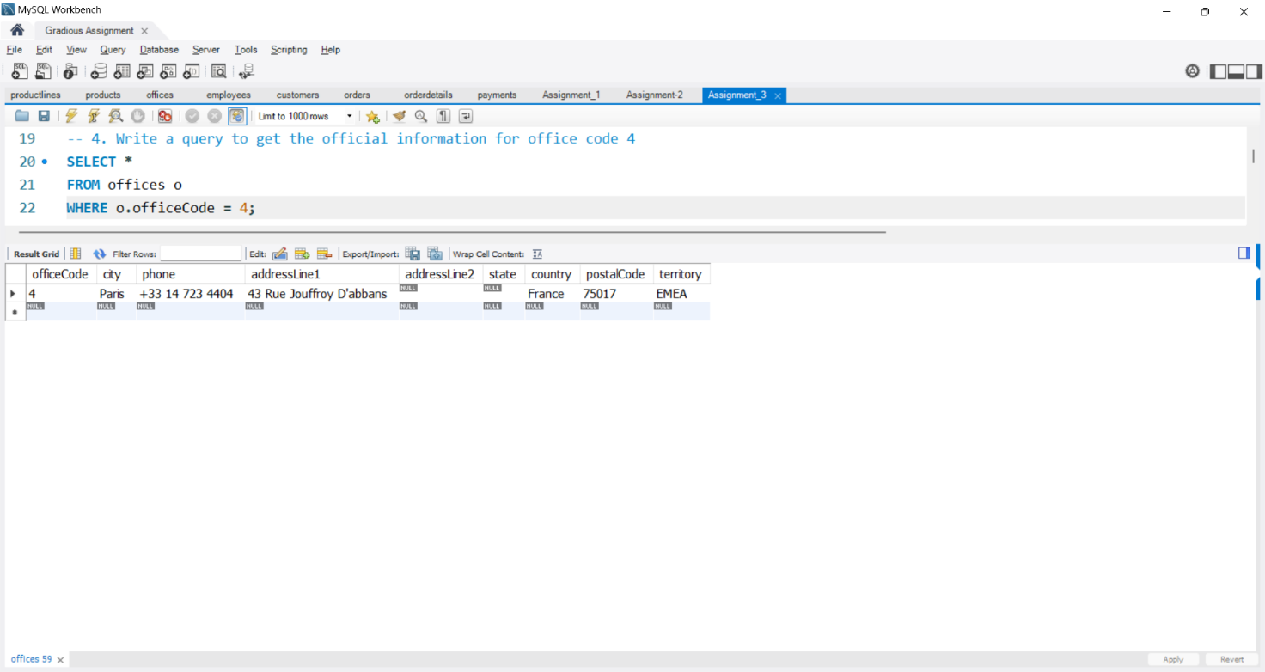

5. Write a query to retrieve the product line for each product in an order.

Query:

SELECT od.*, p.productLine

FROM products p

JOIN orderdetails od ON p.productCode = od.productCode;

Output:

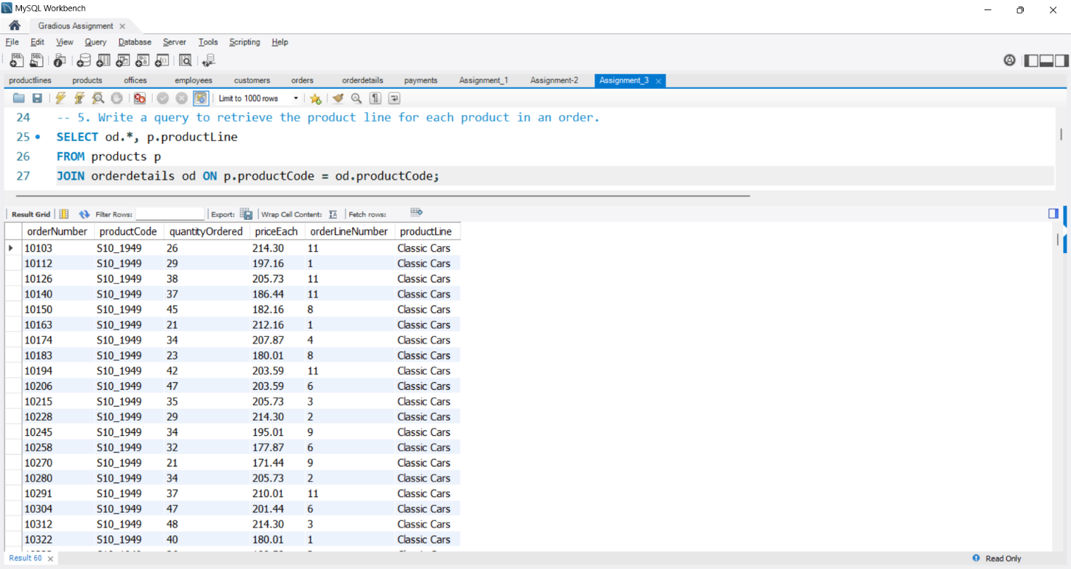

6. Write a query to get the customer information and order status for all orders that contain products belonging to the 'Classic Cars' product line.

Query:

SELECT c.*, o.status

FROM products p

JOIN orderdetails od ON p.productCode = od.productCode

JOIN orders o ON od.orderNumber = o.orderNumber

JOIN customers c ON o.customerNumber = c.customerNumber

WHERE p.productLine = 'Classic Cars';

Output:

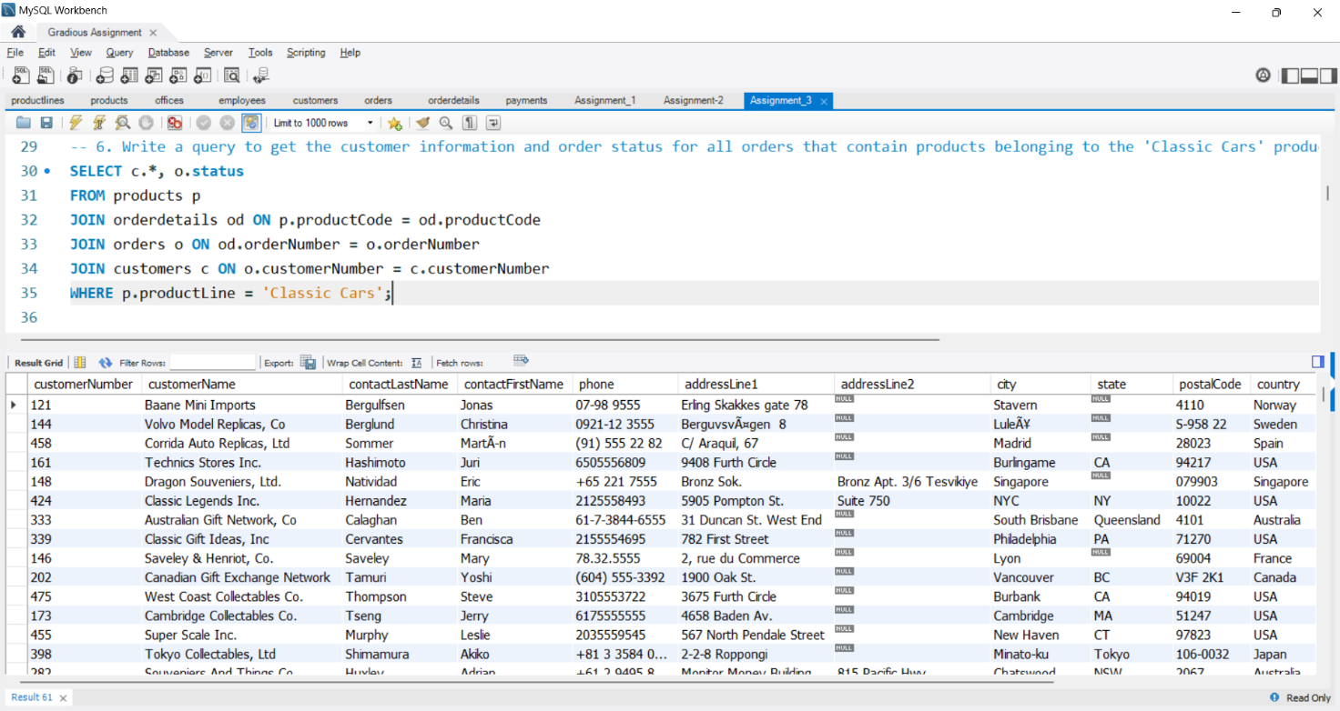

7. Write a query to retrieve the payment details and customer details of customer number 103

Query:

SELECT c.*, p.*

FROM customers c

JOIN payments p ON c.customerNumber = p.customerNumber

WHERE c.customerNumber = 103;

Output:

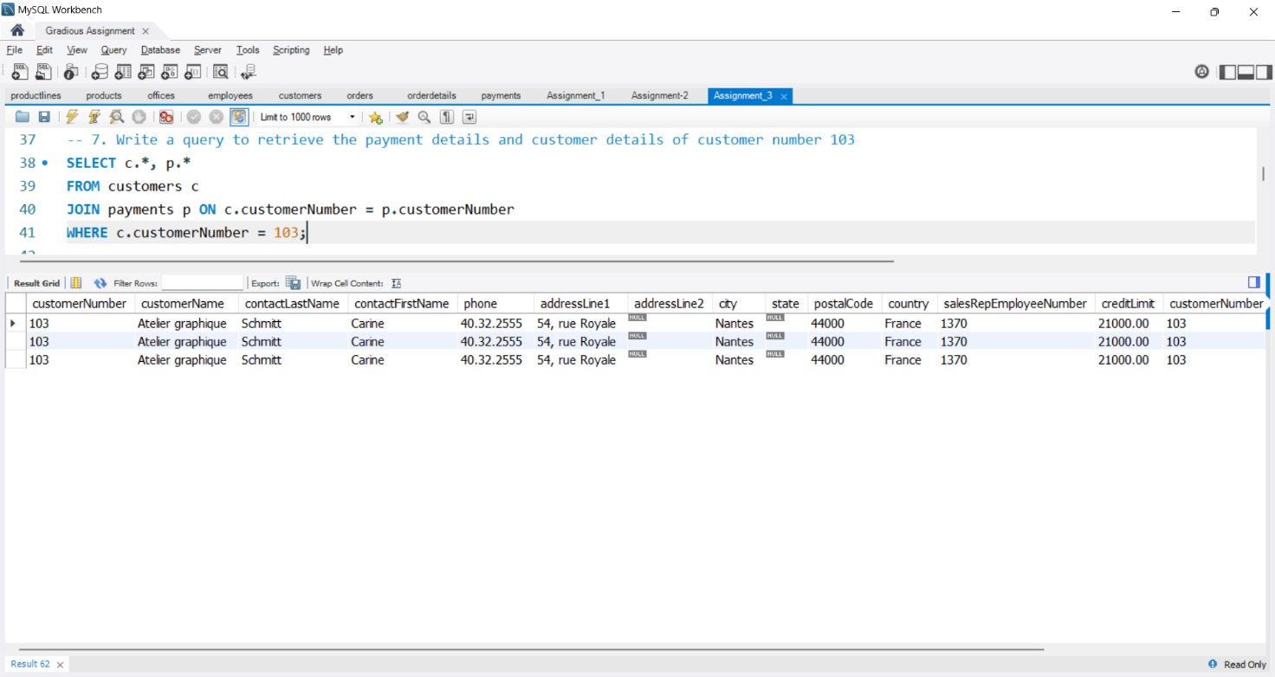

8. Write a query to get the orders and their corresponding payments to the same customer.

Query:

SELECT o.*, p.checkNumber, p.paymentDate, p.amount

FROM orders o

JOIN payments p ON o.customerNumber = p.customerNumber;

Output:

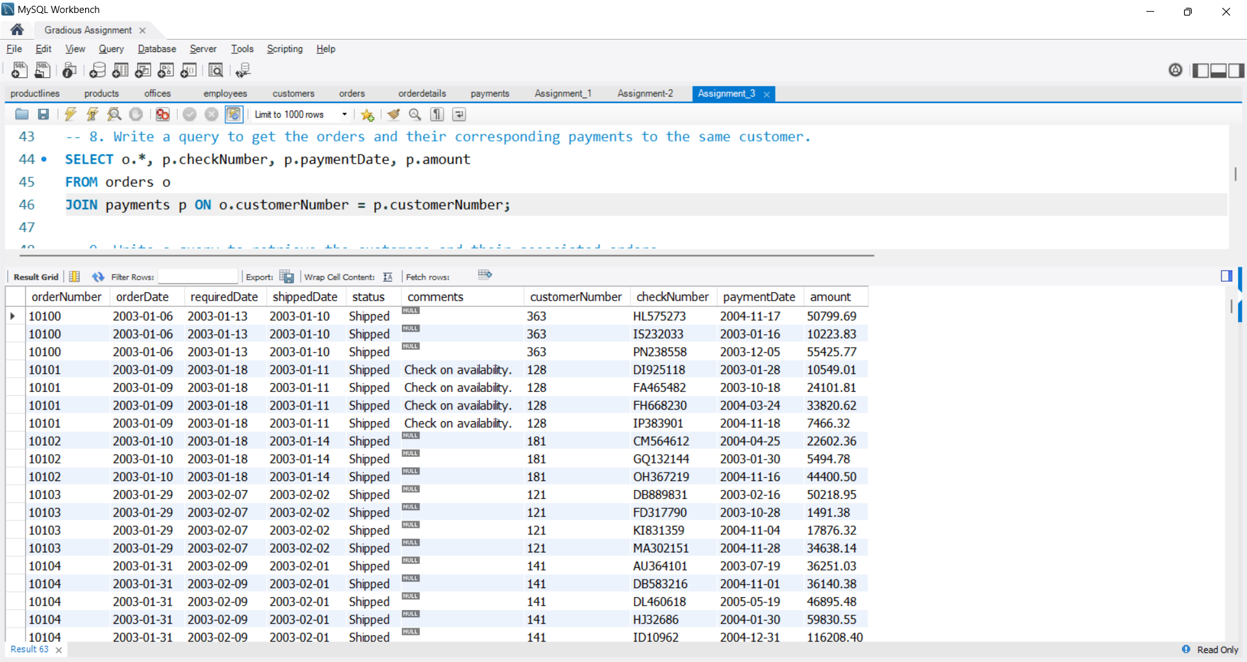

9. Write a query to retrieve the customers and their associated orders.

Query:

SELECT *

FROM customers c

JOIN orders o ON c.customerNumber = o.customerNumber;

Output:

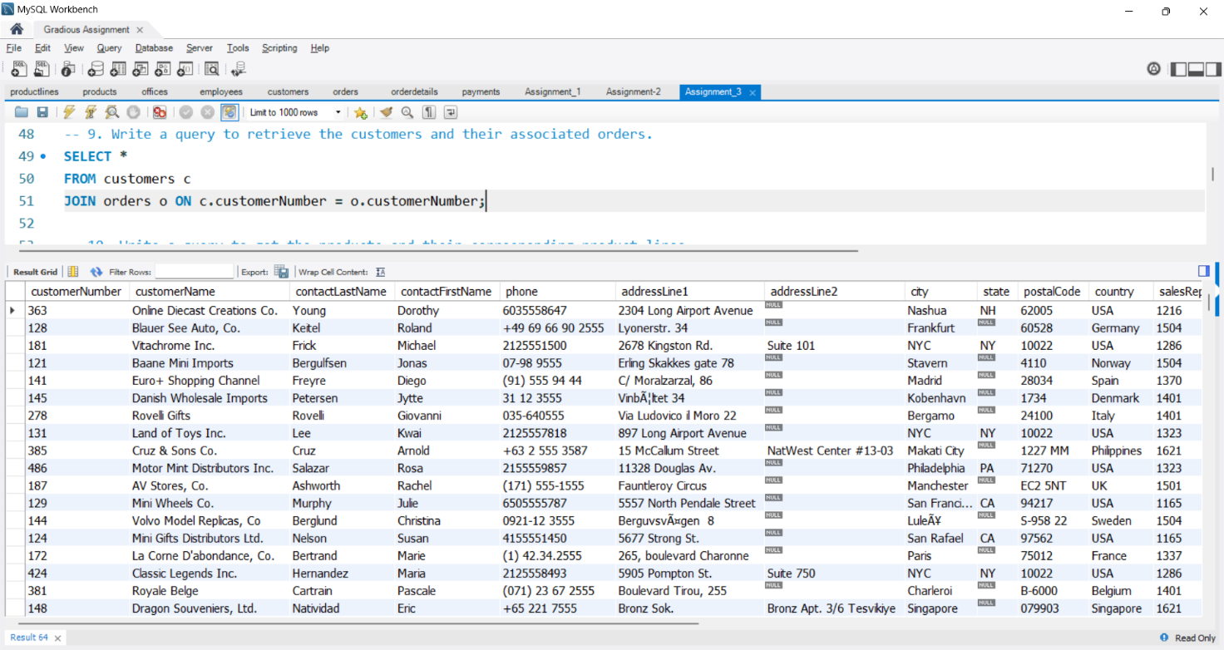

10. Write a query to get the products and their corresponding product lines.

Query:

SELECT *

FROM products p

JOIN productLines pl ON p.productLine = pl.productLine;

Output:

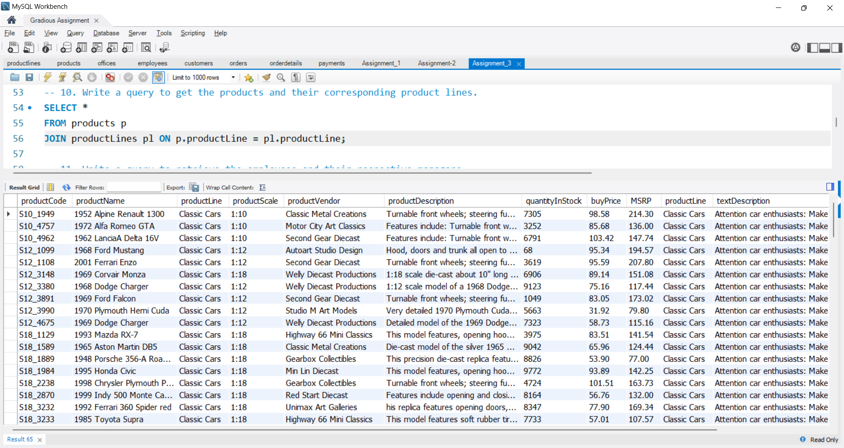

11. Write a query to retrieve the employees and their respective managers.

Query:

SELECT *

FROM employees e

JOIN employees es ON e.reportsTo = es.employeeNumber;

Output:

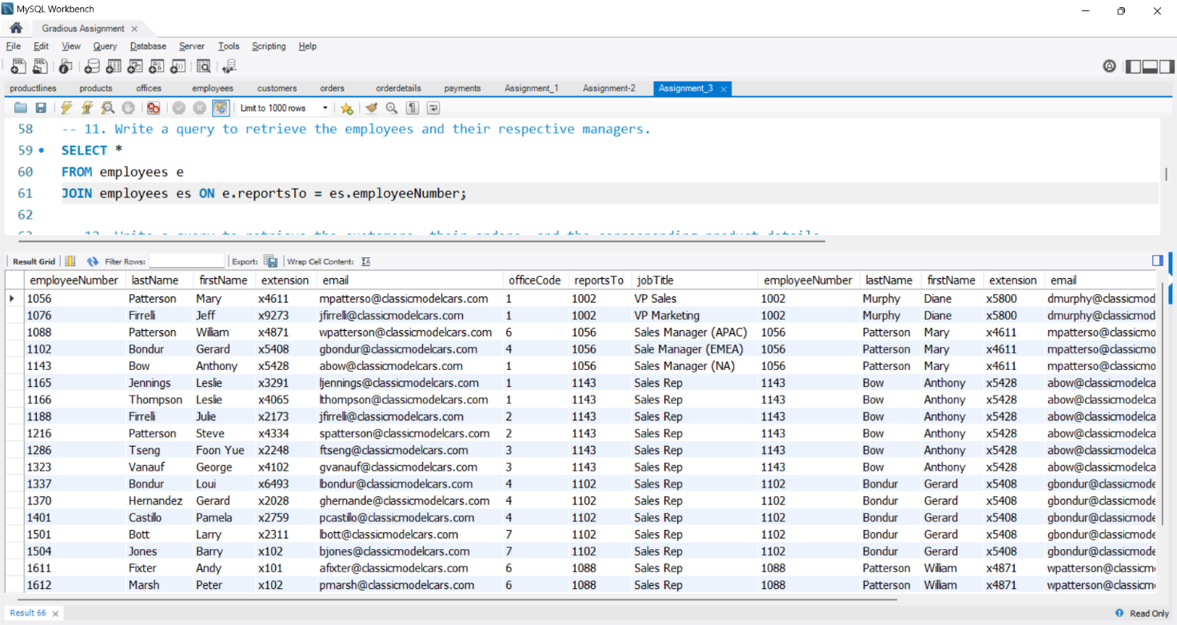

12. Write a query to retrieve the customers, their orders, and the corresponding product details.

Query:

SELECT *

FROM customers c

JOIN orders o ON c.customerNumber = o.customerNumber

JOIN orderdetails od ON o.orderNumber = od.orderNumber

JOIN products p ON od.productCode = p.productCode;

Output:

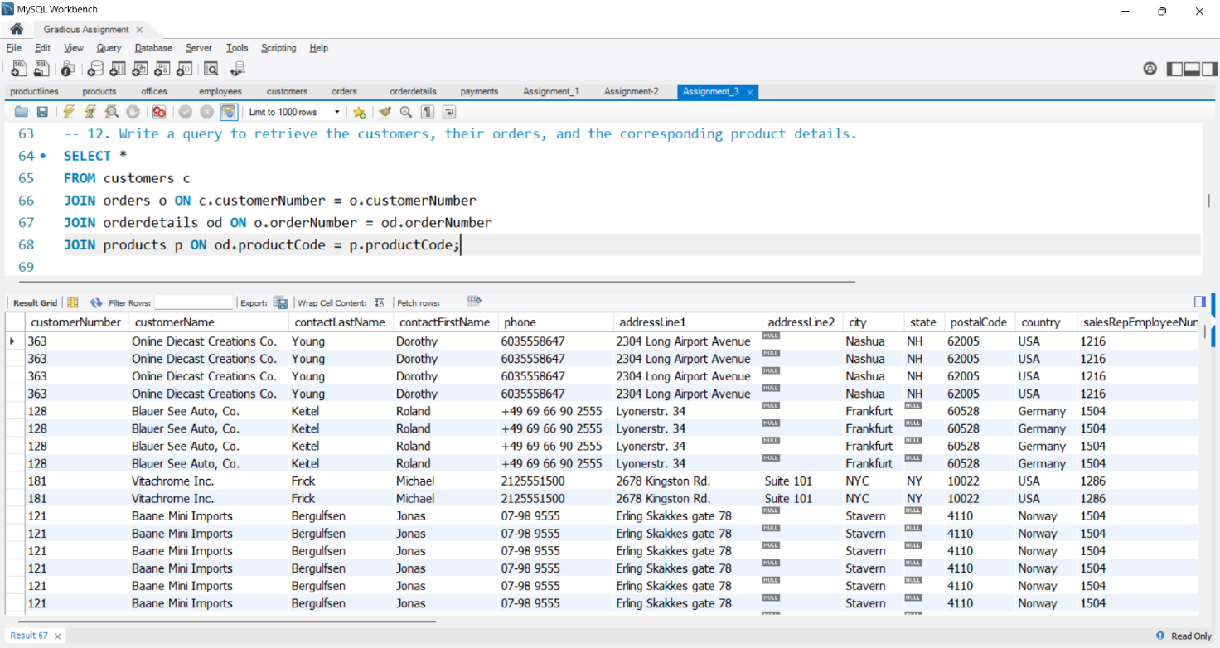

13. Write a query to get the payment details, order details, and the associated products.

Query:

SELECT *

FROM orders o

JOIN orderdetails od ON o.orderNumber = od.orderNumber

JOIN products p ON od.productCode = p.productCode

JOIN payments py ON o.customerNumber = py.customerNumber;

Output:

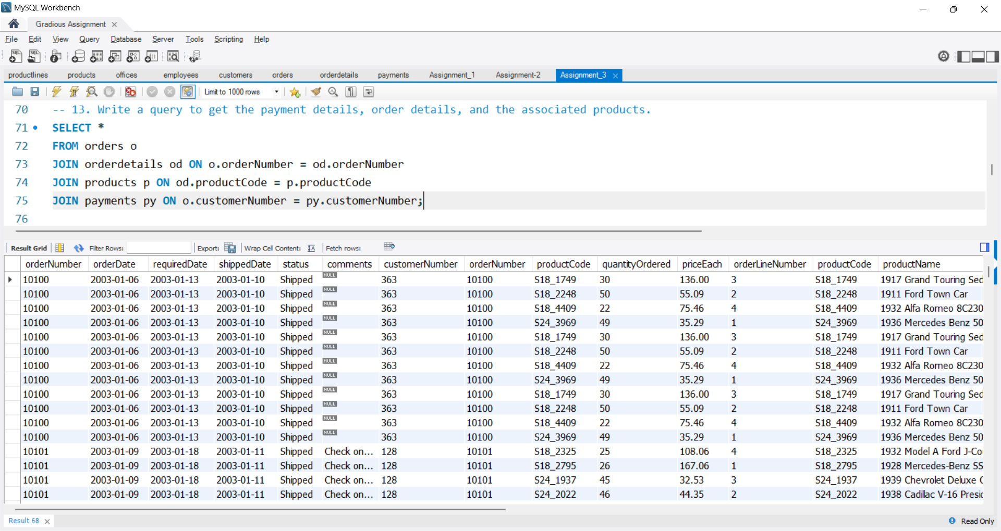

14. Write a query to retrieve the payment details and the customer information for the check number JM555205

Query:

SELECT *

FROM payments p

JOIN customers c ON p.customerNumber = c.customerNumber

WHERE p.checkNumber = 'JM555205';

Output:

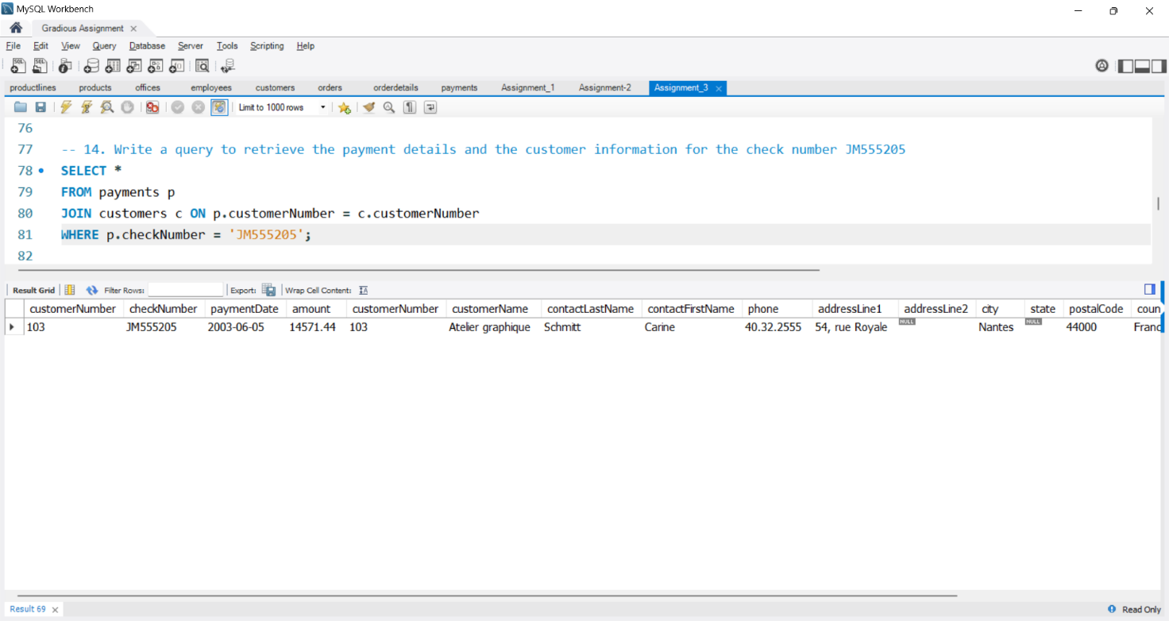

15. Write a query to retrieve the orders and their corresponding customer and employee information for a canceled status.

Query:

SELECT *

FROM orders o

JOIN customers c ON o.customerNumber = c.customerNumber

JOIN employees e ON c.salesRepEmployeeNumber = e.employeeNumber

WHERE o.status = 'Cancelled';

Output:

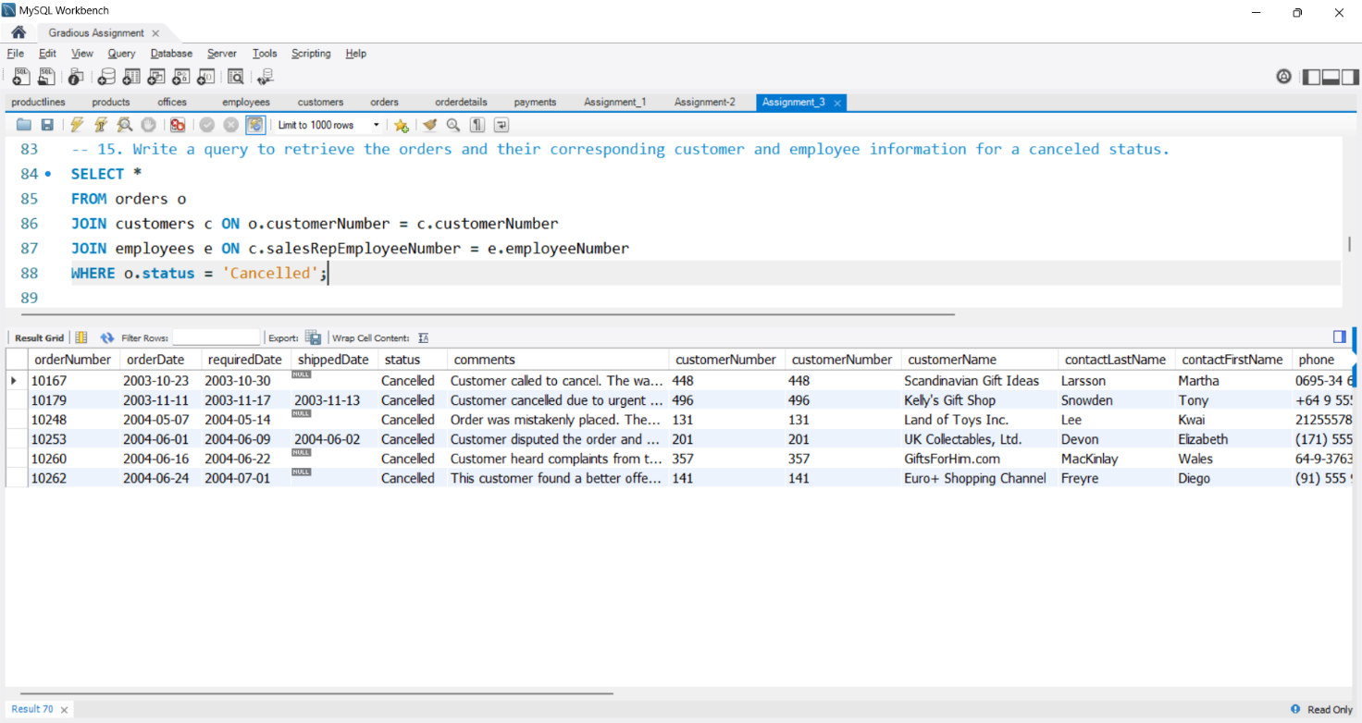

16. Write a query to get the payments, order details, and associated product information for the pavment date 2004-12-17.

Query:

SELECT *

FROM payments py

JOIN orders o ON py.customerNumber = o.customerNumber

JOIN orderdetails od ON o.orderNumber = od.orderNumber

JOIN products p ON od.productCode = p.productCode

WHERE py.paymentDate = '2004-12-17';

Output:

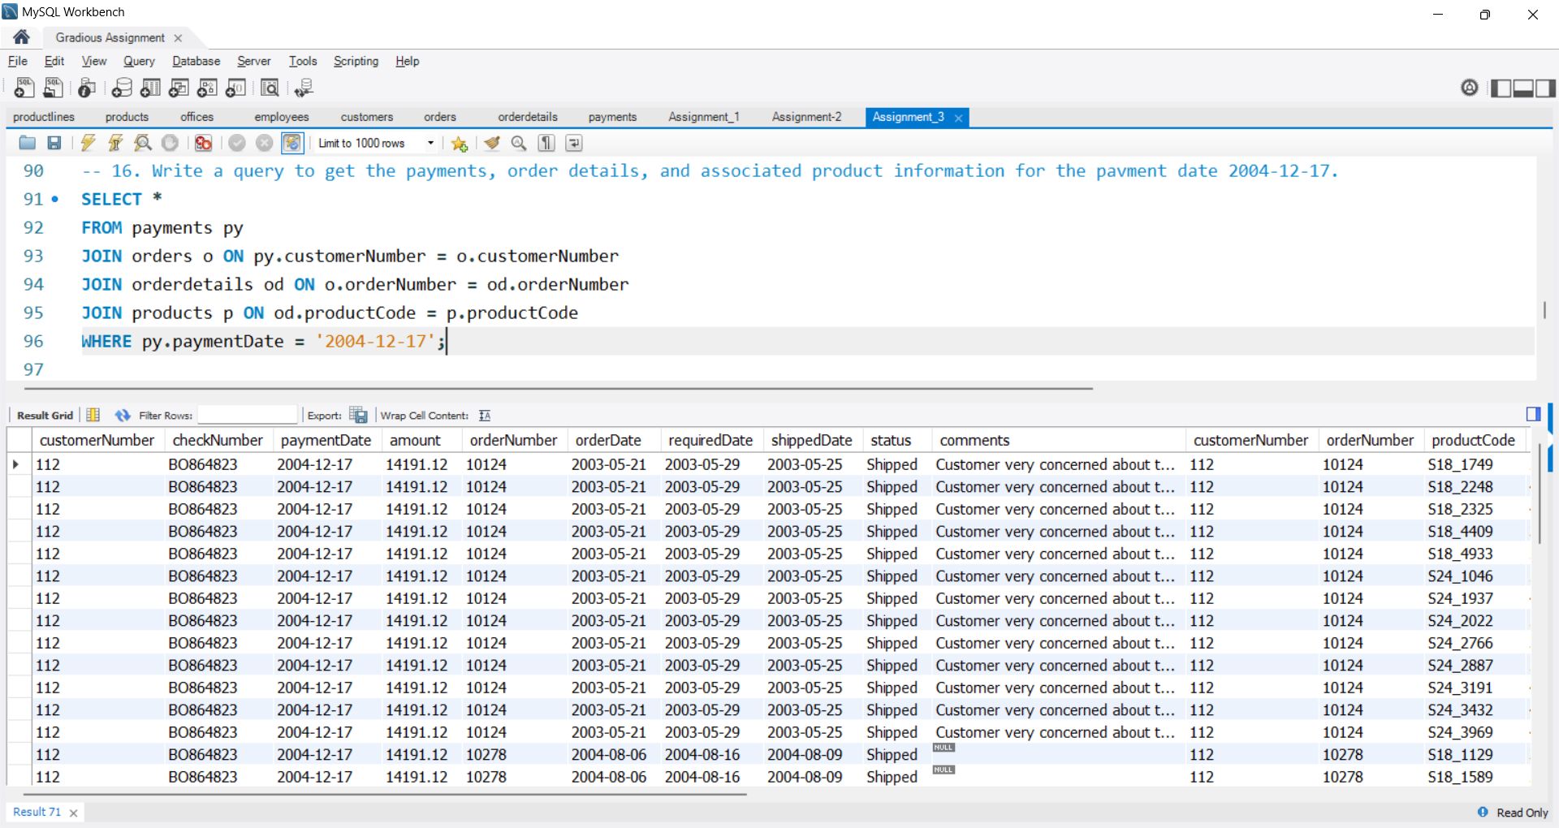

17. Write a query to retrieve the products, order details, and corresponding customer information for customer 112

Query:

SELECT *

FROM orders o

JOIN orderdetails od ON o.orderNumber = od.orderNumber

JOIN products p ON od.productCode = p.productCode

WHERE o.customerNumber = 112;

Output:

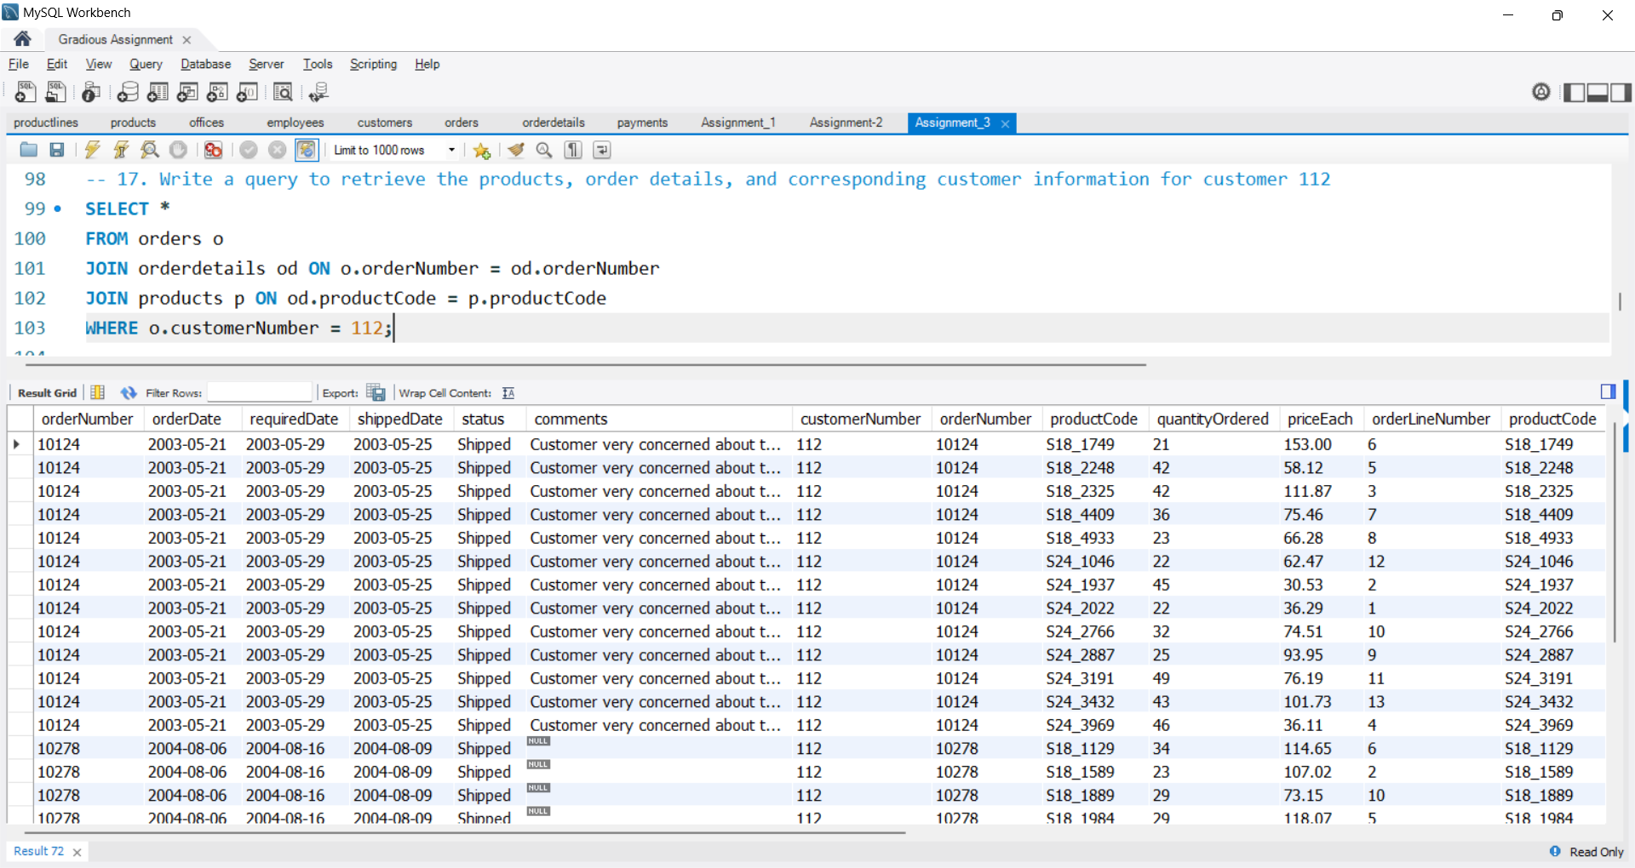

18. Write a query to retrieve the customers, their orders, and the associated product line information for the customers who are all from Boston,

Query:

SELECT c.*, o.*, od.*, p.productLine

FROM customers c

JOIN orders o ON c.customerNumber = o.customerNumber

JOIN orderdetails od ON o.orderNumber = od.orderNumber

JOIN products p ON od.productCode = p.productCode

WHERE c.city = 'Boston';

Output:

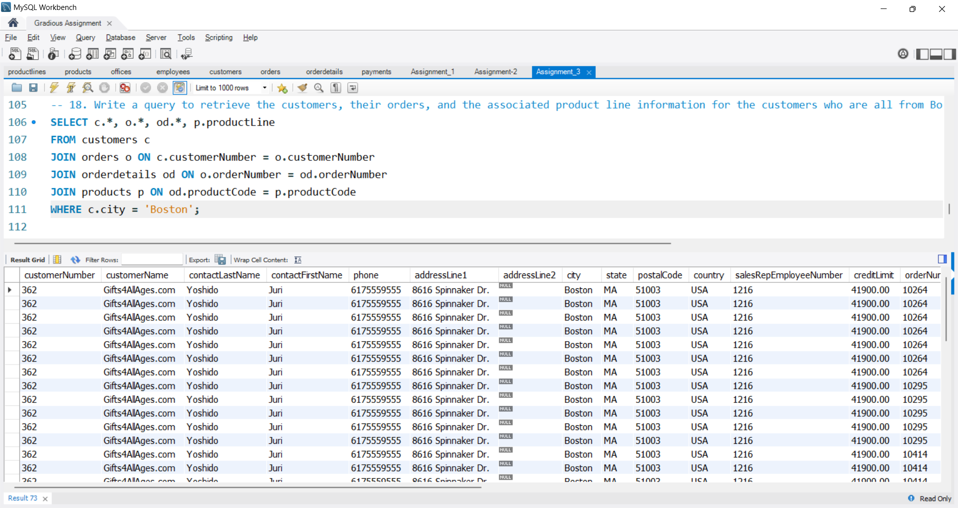

19. Write a query to get the employees, their respective managers, and the corresponding office details of the Sales Rep.

Query:

SELECT *

FROM employees e

JOIN employees es ON e.reportsTo = es.employeeNumber

JOIN offices o ON e.officeCode = o.officeCode

WHERE e.jobTitle = 'Sales Rep';

Output:

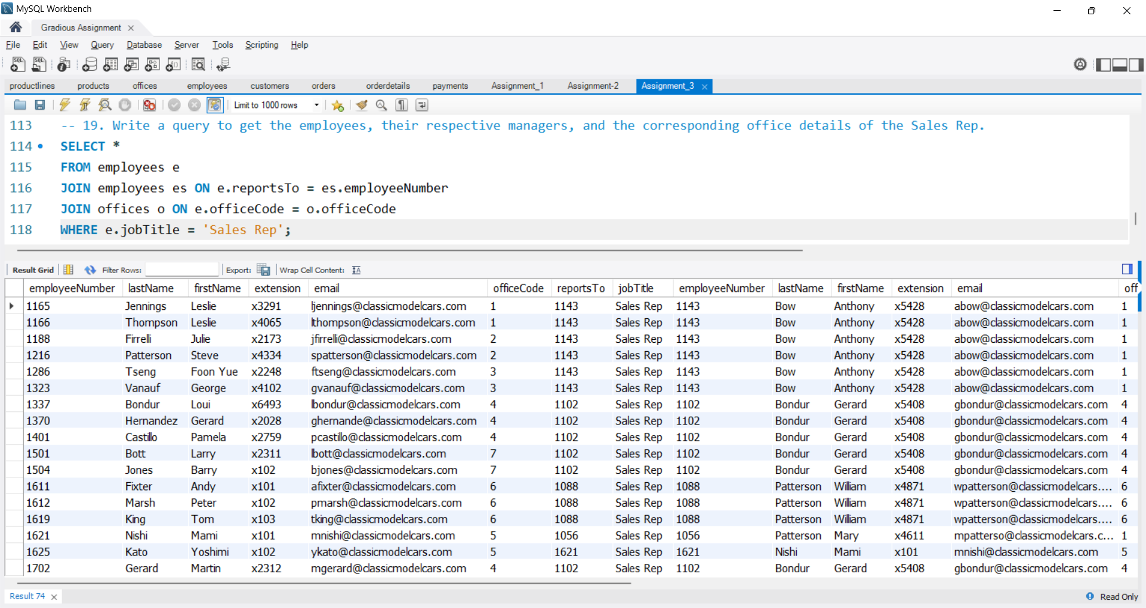

20. Write a query to retrieve the product lines, products, and the corresponding customer information for Vintage Cars.

Query:

SELECT *

FROM customers c

JOIN orders o ON c.customerNumber = o.customerNumber

JOIN orderdetails od ON o.orderNumber = od.orderNumber

JOIN products p ON od.productCode = p.productCode

WHERE p.productLine = 'Vintage Cars';

Output:

